Links

Definition:
# Source: AI Source: Provided by: [Data Path: Persons Table -> ID Column: 1, Name_En Column: Motasem Essam] -> From: [Chatgpt (GPT‑5 Mini)] on [2/12/2026]
Links are web page components that allow users to navigate from one page or website to another. They are one of the most fundamental elements of the web.

Simple Definition
# Source: AI Source: Provided by: [Data Path: Persons Table -> ID Column: 1, Name_En Column: Motasem Essam] -> From: [Chatgpt (GPT‑5 Mini)] on [2/12/2026]
Links = clickable text, images, or buttons that take users to another page or section.

What Links Usually Include
# Source: AI Source: Provided by: [Data Path: Persons Table -> ID Column: 1, Name_En Column: Motasem Essam] -> From: [Chatgpt (GPT‑5 Mini)] on [2/12/2026]
- Anchor text – highlighted text that users can click
- URL / destination – the page, section, or website the link points to
- Optional styling – color changes, underlines, or hover effects
- Internal links – go to another page within the same website
- External links – go to a different website
- Anchor links – scroll to a specific section on the same page

Purpose of Links
# Source: AI Source: Provided by: [Data Path: Persons Table -> ID Column: 1, Name_En Column: Motasem Essam] -> From: [Chatgpt (GPT‑5 Mini)] on [2/12/2026]
- Enable navigation within a website or across websites
- Connect related information and resources
- Improve user experience and website structure
- Help with SEO (Search Engine Optimization) by linking content

Examples
# Source: AI Source: Provided by: [Data Path: Persons Table -> ID Column: 1, Name_En Column: Motasem Essam] -> From: [Chatgpt (GPT‑5 Mini)] on [2/12/2026]
- “Read More” link → goes to a full article
- Menu links → Home, About, Contact
- “Visit our partner site” → external link to another website
- Table of contents → jump to sections on the same page

Difference Between Links and Buttons / CTA
# Source: AI Source: Provided by: [Data Path: Persons Table -> ID Column: 1, Name_En Column: Motasem Essam] -> From: [Chatgpt (GPT‑5 Mini)] on [2/12/2026]
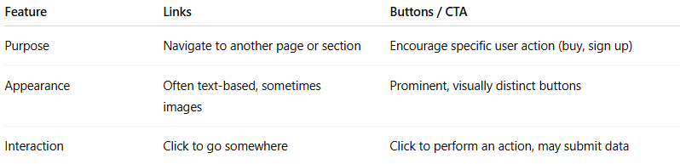
Feature | Links | Buttons / CTA
Purpose | Navigate to another page or section | Encourage specific user action (buy, sign up)
Appearance | Often text-based, sometimes images | Prominent, visually distinct buttons
Interaction | Click to go somewhere | Click to perform an action, may submit data

